|  |  |  |
| --- | --- | --- |
| **RMINISTRY OF EDUCATION**  **IMAM ABDULRAHMAN BIN**  **FAISAL UNIVERSITY**  **COLLEGE OF COMPUTER SCIENCE**  **& INFORMATION TECHNOLOGY** | **وزارة التعليم**  **جامعة الإمام**  **عبدالرحمن بن فيصل**  **كلية علوم الحاسب**  **وتقنيةالمعلومات** |  |

**CS 411 – Software Engineering**

**Term 1 – 2018/2019**

**Project Proposal Form**

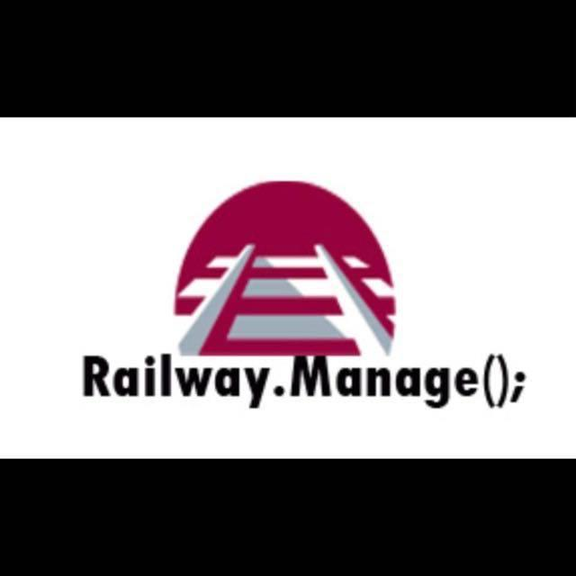

* **Group #: 1**
* **Members of the group:**

|  |  |  |  |
| --- | --- | --- | --- |
| # | Name | ID | Role |
| 1 | Muneera abdullah alhajri | 2160007230 | Leader |
| 2 | Reema Ibrahim Alyousef | 2160003133 | Member |
| 3 | Rahaf Saleh Alzahrani | 2160006662 | Member |
| 4 | Tasneem Hamdy dosoqi | 2160007430 | Member |

* **Title of the Project: Railway. Manage();**
* **Introduction of the Project - Problem Statement:**

The goal of this program is to create a digital environment that eases the organization and maintenance of a train station,by enabling the passengers to access the time table of the station,book a trip or inquire about their ticket info at any time.

By achieving those functionalities,this program will work as a conduit for passengers to access and control their trips through the comfort of their technological gadgets.

Moreover,operators will be able to access special features that are available to them such as being able to edit,add or delete a trip into the station’s timetable.

Additionally,it will combine all of the features a passenger would need to travel via train into one place that is made easy to navigate and use.

* **Objectives (Product Characteristics and Requirements):**
* The final software will be run solely on a PC.
* The program must allow for booking a ticket through multiple stages…

1. The user will firstly check the train’s schedule to choose the trip they wish to travel on.
2. The user will be transported to the booking window, where they will select the trip, class (Gold,Silver,or Economic),number of passengers, departure and arrival station and date of trip.
3. The next step is to the seat selection window, where the passenger will be asked to choose their desirable seat\s.
4. After booking, the user will be asked to enter their personal information and contact info.

* When booking is completed, the passenger is allowed to inquire about their ticket at any time.
* The budget must not exceed 25.000.
* The program hat to run on multiple operating systems(Windows,Mac, Or linux)
* Due date is on Aprile 2019
* Making a fully functioning operator feature, that allows them to edit into the station’s timetable.
* **Project end user:**

|  |  |  |
| --- | --- | --- |
|  | **User Role**  *(at least two user roles)* | **Privileges**  *(User Roles should vary in their privileges)* |
| **1** | **Operators** | **Are able to view all information without restriction and edit the elements freely. However, they cannot add or delete an entity.** |
| **2** | **User** | **Is able to just view the Departures and arrivals table, book from it and access their own ticket.** |

* **Summary of Project Deliverables:**

Railway.Manage ( ) ; is one-stop software that delivers different functionalities to both the passengers (users) and the operator of the train station to meet their needs. passengers will concern only about their ticket and they will be able to access and review timetable of the station, book a trip, inquires and monitors their ticket or check the trip schedule during booking the ticket,

the passengers can choose their seats among different classes in other hand, operators are responsible about all aspects of the system. there is no restrictions for

them because they allowed to access each component of the system. They can view timetable for

each train and edit them. Also, they have permission to access passengers tickets and their

detailed information in order to maintain the work of station.This application we will do it by:

- Application code applied by java programming language

- Database design and constructions

- All documentation needed to granite that team is applying the decided plan According to that, to deliver our program efficiency and during the decided deadline within a specific output, we will break down the project in to tasks and it will be distributed on the team members, to granite that every member of the team takes an appropriate amount of the work equally, also

to make sure that all the members will develop their skills and gather all information needed to deliver the final project, after finishing the tasks we will firm it by testing all certain methods, and by validating and evaluating the software according to ensure it bugs free .To accomplish our goal we will work under a cetin plan, within a specific timeline, but first of all, we will work in the requirements, then designing the program, after that is testing stage with evaluating and ending with present it.

* **Project Success Criteria:**

After completing the project, it will result in a software that is capable of completing these following features without running into errors:

-The passenger should be able to book a trip,and go through all of the stages of doing so without issues (Entering their information-selecting a trip then choosing a seat)

-When the user enters any input, it should be saved in the corresponding table in the database successfully.

-If a user chooses to display a ticket, all of the information contained in the ticket should show accordingly.

-The operators should be able to access all the features that are available to them(edit, add or delete a trip from the station schedule) and they must be executed correctly.

-The station schedule is expected to display all of the trips and their information.

-The operator and the common user both have distinct interfaces to interact with.

* **Signatures of group members**

|  |  |  |  |
| --- | --- | --- | --- |
| # | Name | ID | Signature |
| 1 | Muneera abdullah alhajri | 2160007230 |  |
| 2 | Reema Ibrahim Alyousef | 2160003133 |  |
| 3 | Rahaf Saleh Alzahrani | 2160006662 |  |
| 4 | Tasneem Hamdy dosoqi | 2160007430 |  |

Date: ………………..…………

**-------------------------------------------------- For instructor use only ------------------------------------------**

Approved Not approved Date: …………………….

Comments: